ID: 320 H
Innovation in HVAC Systems 2
Protection and Air-Conditioning Concept in Emergency and Rescue Train
קונספט מיגון ומיזוג אוויר ברכבת חירום והצלה
Samuel Koeger
Beth-El Industries, Israel
s.koeger@beind.com 054-2660204
A protection concept and air-filtration and air-condition system was developed for an emergency- and rescue train to deal with accidents and fires in tunnels.
The train consists of 3 main wagons for:
a. Rescue team and firefighting equipment
b. Water and material for fire fighting
c. Patients and (rescued) passengers
At tunnel accidents and tunnel fires, extreme heat and highly toxic gasses may be present. Therefore, the wagons have to be equipped with air-filtration systems and air-conditions systems to protect both, the rescue team and as well the patients and rescued passengers.
The air-filtration system includes several filtration stages, like:
a. Dust filters
b. HEPA filters
c. Gas-filters against toxic fumes (ABEK-class)
d. Carbon monoxide (CO) filters
The air-filtration system and air-condition system is equipped with sensors, like:
a. Temperature sensors
b. Overpressure sensors
c. Airflow sensors
d. Oxygen (O2) sensors
e. Carbon monoxide (CO) sensors
f. Carbon dioxide (CO2) sensors
g. VOC sensors

which send the signals to the integrated main-controller of the air-filtration and air-conditioning system.
A prototype was manufactured, tested and qualified to:
a. Cooling performance In the climate chamber
b. Air quality and air flow rate
c. Shock- and vibration
d. Electromagnetic (EMC) compatibility
e. Etc.
The protection concept, the development and design considerations, the test setup and test results will be presented and explained.
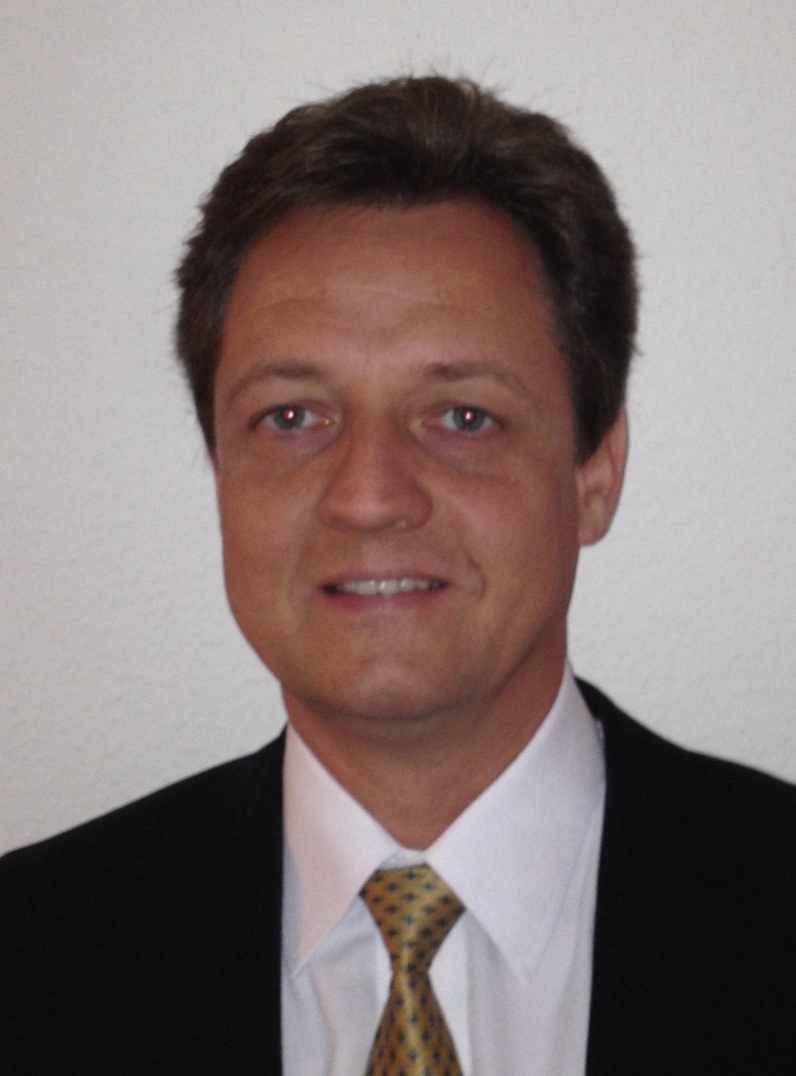
Mr. Samuel Koeger is Technical Director in Beth-El Zikhron Yaaqov Industries Ltd, Israel.
He gained his professional experience in the position of Head of Testing Department, Head of R&D Department, Head of Regional International Marketing and Sales Department and currently as Technical Director in Beth-El Industries.
He holds 32 patents and is a member of the Standard Committee in Israel dealing with air purification, blast protection and CBRN protection systems.

